**Deploying Web App with Docker, GitHub & ELK Monitoring - DevSec SAST & DAST**

Summary -

In the contemporary software development environment, the integration of security into the DevOps pipeline is essential for creating resilient and secure applications.

This project focuses on the design and implementation of an end-to-end DevSecOps CI/CD pipeline using AWS services, enhanced with Static Application Security Testing (SAST) and Dynamic Application Security Testing (DAST) tools.

The pipeline aims to automate and streamline the software development lifecycle by incorporating AWS CodePipeline, CodeBuild, and CodeDeploy to manage code integration, builds, and deployments. Security is integrated throughout the process, with SAST tools employed to analyze source code for vulnerabilities early in the development phase, and DAST tools used to assess the runtime behavior of applications to identify potential security issues in real time.

The primary objectives of this project include creating a seamless and automated CI/CD pipeline that embeds rigorous security checks, reducing the risk of vulnerabilities, and ensuring compliance with security best practices. By integrating these tools into the pipeline, the project demonstrates how automated security testing can be effectively embedded into continuous integration and deployment workflows, enhancing both the security posture and efficiency of software development practices. This approach not only accelerates the development cycle but also ensures that security is a fundamental component of the development process.

Tools

Sonar Qube (SAST)

OWASPZAP (DAST)

Trivy (ContainerSecurity)

Jenkins

Github

Docker

ELK

AWS

Flow

Code → Github→ Jenkins →SAST → DAST → Docker → AWS

ELK

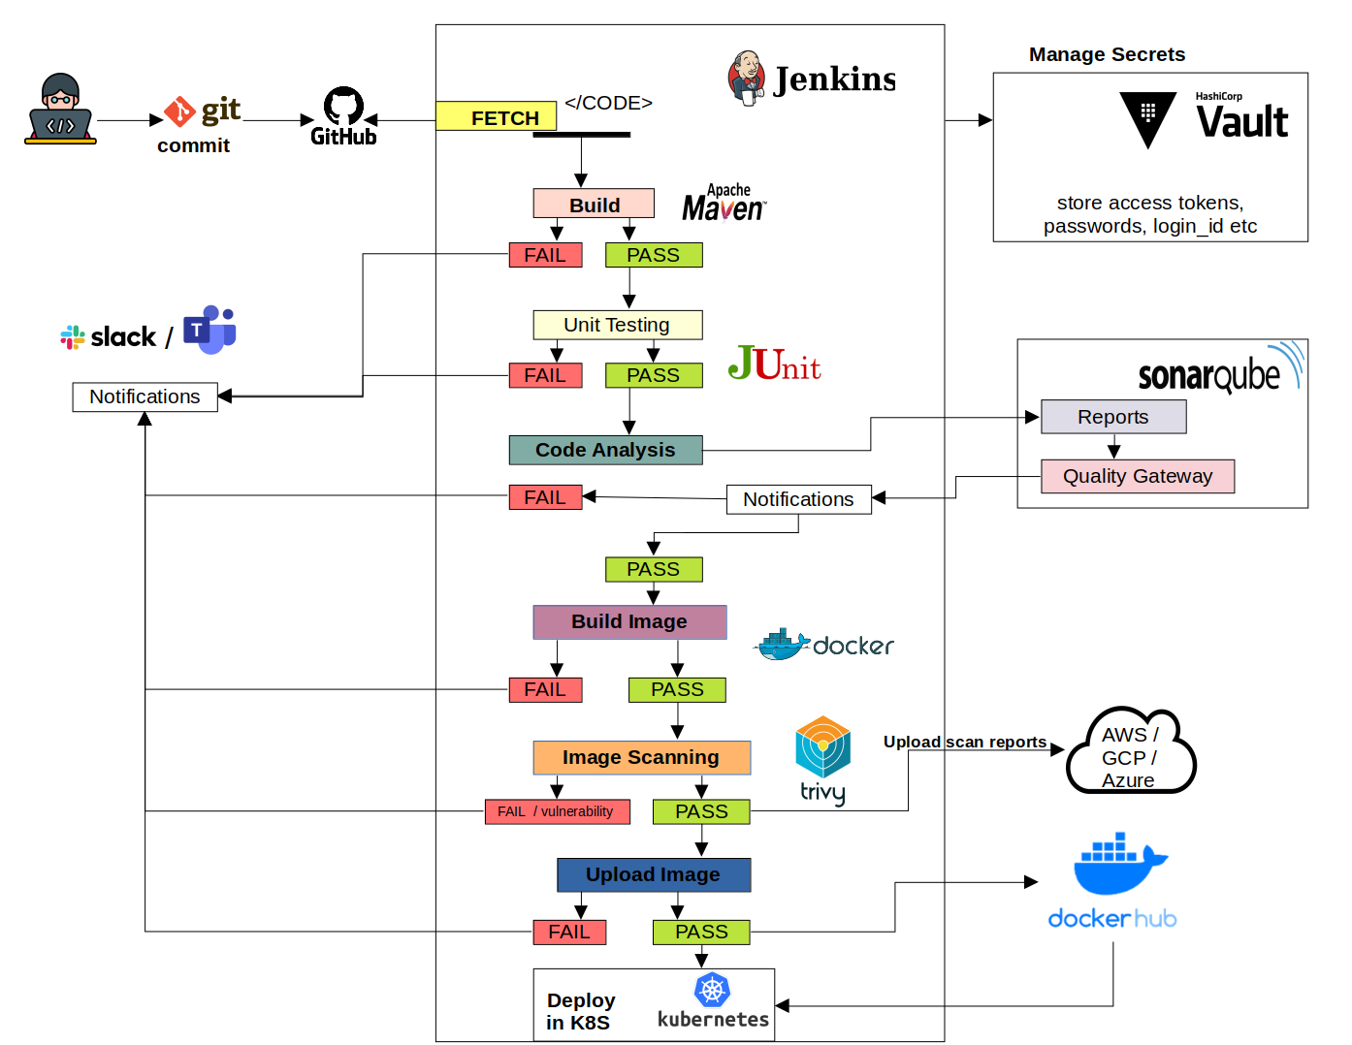

<https://github.com/DITISS-AUG24-PROJECT/A1>

Project Workflow -

**day 1 - 27-01-2025**

Team-a : Dhanashri & Jaspreet - Docker & Jenkins

Team-b : Divyansh - ELK Server

Team-c : Samrajya & Akshat - SonarQube, OWASP ZAP & Trivy

Day 2 28-01-2025 Target

Task 1 - Integrate All Configuration

Task 2 - Migrate environment to AWS Cloud

Day 3 - 29-01-2025

Task 1 - Web App Development

Task 2 - Documentation

Task 3 - Presentation